**Birthday Products**

# **1.Artificial Roses:**

**At [Blooming Petal], we specialize in creating enchanting birthday flower decorations that elevate your celebrations to new heights. With a passion for floral artistry, we design bespoke arrangements that suit your unique theme and preferences. From vibrant and playful designs for kids' birthdays to sophisticated and elegant setups for adult parties, our talented team ensures every detail is meticulously crafted. Whether it's decorating the venue, creating stunning centerpieces, or crafting beautiful floral gifts, we add a touch of natural beauty and joy to your special day. Let our floral masterpieces make your birthday celebrations truly unforgettable, leaving you and your guests captivated by the magic of our creations.**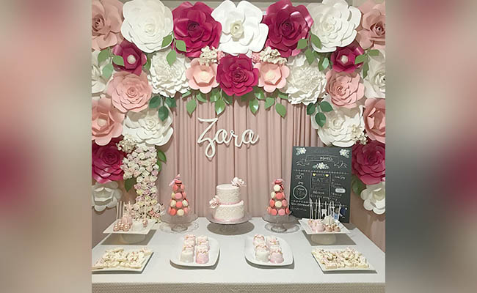

# **2.Mix Flowers and Balloons:**

**At [Blooming Petal], we specialize in creating enchanting birthday flower decorations that elevate your celebrations to new heights. With a passion for floral artistry, we design bespoke arrangements that suit your unique theme and preferences. From vibrant and playful designs for kids' birthdays to sophisticated and elegant setups for adult parties, our talented team ensures every detail is meticulously crafted. Whether it's decorating the venue, creating stunning centerpieces, or crafting beautiful floral gifts, we add a touch of natural beauty and joy to your special day. Let our floral masterpieces make your birthday celebrations truly unforgettable, leaving you and your guests captivated by the magic of our creations.**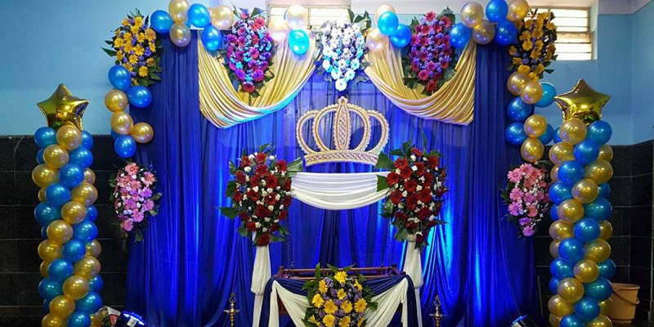

# **3.Italian Decorations:**

**At [Blooming Petal], we specialize in creating enchanting birthday flower decorations that elevate your celebrations to new heights. With a passion for floral artistry, we design bespoke arrangements that suit your unique theme and preferences. From vibrant and playful designs for kids' birthdays to sophisticated and elegant setups for adult parties, our talented team ensures every detail is meticulously crafted. Whether it's decorating the venue, creating stunning centerpieces, or crafting beautiful floral gifts, we add a touch of natural beauty and joy to your special day. Let our floral masterpieces make your birthday celebrations truly unforgettable, leaving you and your guests captivated by the magic of our creations.**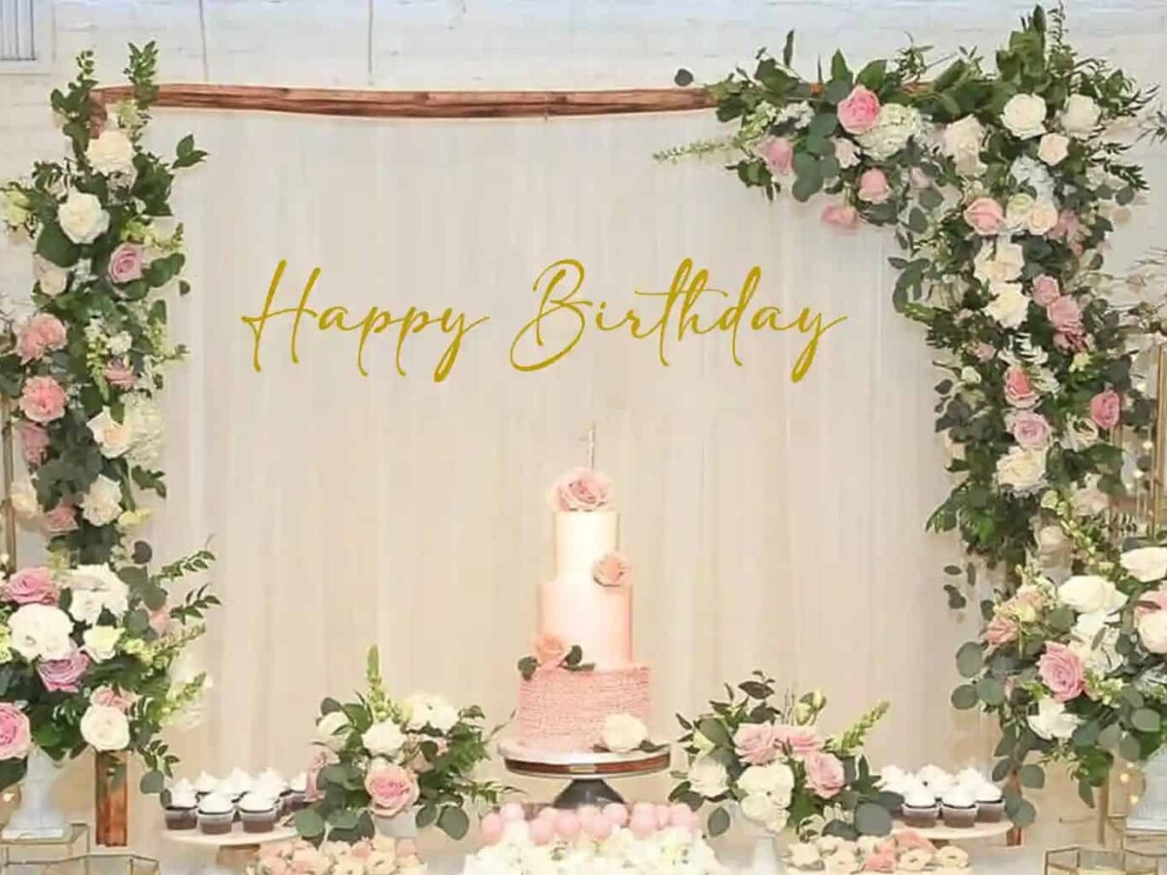

# **4.Barbie Theme:**

**At [Blooming Petal], we specialize in creating enchanting birthday flower decorations that elevate your celebrations to new heights. With a passion for floral artistry, we design bespoke arrangements that suit your unique theme and preferences. From vibrant and playful designs for kids' birthdays to sophisticated and elegant setups for adult parties, our talented team ensures every detail is meticulously crafted. Whether it's decorating the venue, creating stunning centerpieces, or crafting beautiful floral gifts, we add a touch of natural beauty and joy to your special day. Let our floral masterpieces make your birthday celebrations truly unforgettable, leaving you and your guests captivated by the magic of our creations.**

# **5.Childrens Decorations:**

**At [Blooming Petal], we specialize in creating enchanting birthday flower decorations that elevate your celebrations to new heights. With a passion for floral artistry, we design bespoke arrangements that suit your unique theme and preferences. From vibrant and playful designs for kids' birthdays to sophisticated and elegant setups for adult parties, our talented team ensures every detail is meticulously crafted. Whether it's decorating the venue, creating stunning centerpieces, or crafting beautiful floral gifts, we add a touch of natural beauty and joy to your special day. Let our floral masterpieces make your birthday celebrations truly unforgettable, leaving you and your guests captivated by the magic of our creations.**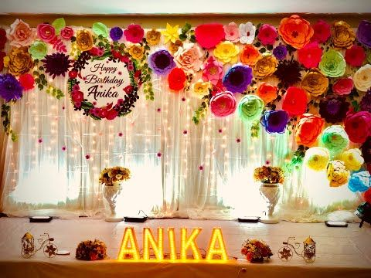

# **6.Carnation with Roses:**

**At [Blooming Petal], we specialize in creating enchanting birthday flower decorations that elevate your celebrations to new heights. With a passion for floral artistry, we design bespoke arrangements that suit your unique theme and preferences. From vibrant and playful designs for kids' birthdays to sophisticated and elegant setups for adult parties, our talented team ensures every detail is meticulously crafted. Whether it's decorating the venue, creating stunning centerpieces, or crafting beautiful floral gifts, we add a touch of natural beauty and joy to your special day. Let our floral masterpieces make your birthday celebrations truly unforgettable, leaving you and your guests captivated by the magic of our creations.**